Lab Assignment 2
Scala Programming
Name: M Jeyapathy
USN: 22BTRAD016

Step 1: Download and install Java.
https://www.java.com/en/download/manual.jsp
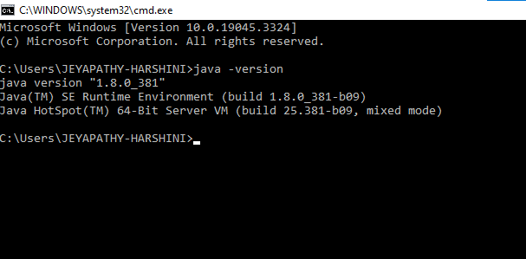

Step2: Download and install Scala
https://www.scala-lang.org/download/
https://www.scala-lang.org/download/2.13.11.html

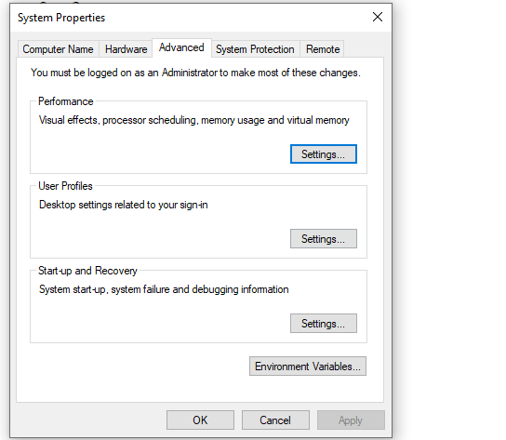
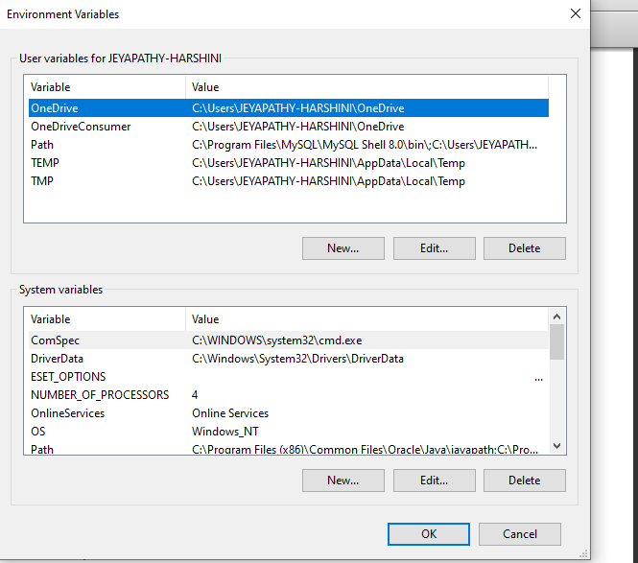
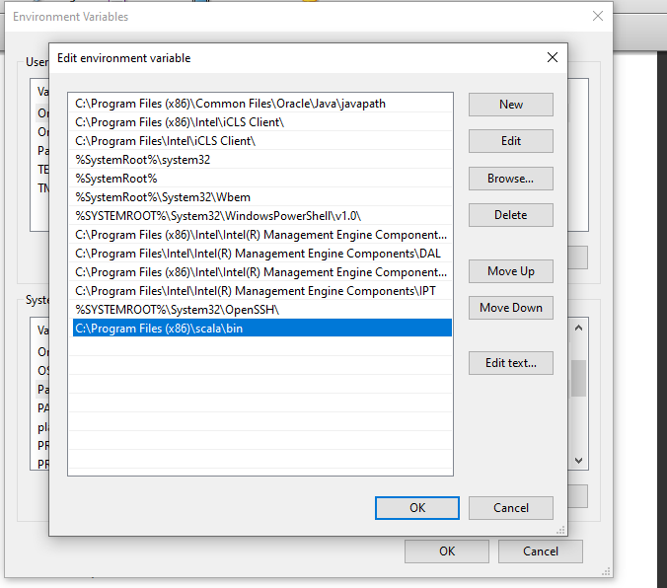
Scala is installed at this path.
Confirm the version with cmd .
